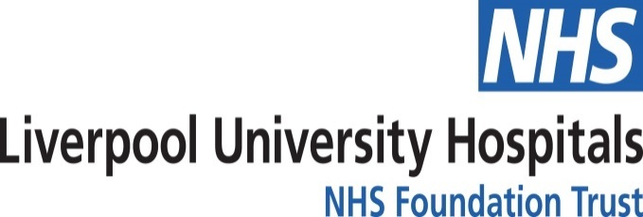

APPLICATION TO PURCHASE ADDITIONAL ANNUAL LEAVE

I wish to apply to purchase additional annual leave for the forthcoming leave year in accordance with the principles set out in the Additional Annual Leave Scheme Guidelines document. Furthermore, I agree to the appropriate deduction from my salary for the period remaining in the current leave year. I understand that no more than 2 Weeks can be purchase in any leave year.

- Part One: To be completed by the requesting employee to Purchase Additional Annual Leave

Full Name: |  | Position:
Department: |  | Assignment Number:
Home Address: |  | Contact Tel Number:
Trust Email Address:

Please quote leave requested in hours – Max of 75 hrs WTE can be authorized between April and September then a max
37.5 hrs WTE from October to November. (Max of 75 hrs WTE in one leave year).

Enter Month of submitted application: |  | No. of Hours:

Please note that the applying period is between April and November of any fiscal year.
- Approved purchased leave will be added to your entitlement - (Apr 24-Mar 25)

Declaration:

I confirm that I have read and understood the guidance set out above and in the Additional Annual Leave Scheme Guidelines. In the event that I leave my employment with the Trust during the leave year I have been granted additional annual leave, I agree to any adjustment to my final salary to allow the Trust to recover any monies which may be owed as a result of my participation in this scheme as no refunds will be given for any untaken purchased leave.

Print Name: |  | Signature:
Date:

- Part Two: To be completed by the Line Manager
- *Please note your typed name will act as your signature.

Name/Signature |  | Contact No:
Position: |  | Email Address:

.
Approved: |  | No. of hours:
Declined: |  | No. of hours:

The Application must be forwarded to the Directorate Manager/ Department General Manager for review/ countersigning.

Part Three: To be completed by the Directorate Manager/ Department General Manager
- *Please note your typed name will act as your signature.

Name/Signature |  | Contact No:
Position |  | Email Address:

Approved: |  | No. of hours:
Declined: |  | No. of hours:

If the application is not approved or only one week of two weeks is approved, please submit reason(s) why below:

Reason: |  | Signature:
Date:

The Application must be countersigned by the Directorate Manager /Department General Manager

OUTCOME:

Approved: | Y/N  (delete as appropriate) | Once approved, the line manager must write to the employee and confirm the application has been approved. The line manager must also send a copy of the signed application form and a copy of the confirmation letter by email to: smartsalary@liverpoolft.nhs.uk for action and also inclusion on the employee's personal file.
Declined: | Y/N  (delete as appropriate) | If the Application has been declined the employee must be informed of the reason(s) by the line manager and a copy of the application must be forwarded to the Salary Sacrifice team for inclusion on the employee's personal file.

PLEASE READ

Buying additional annual leave will reduce an employee's net pay and it may reduce pension scheme contributions if retiring within the next 3 years. Please ensure that you read the Additional Annual Leave Guidelines and the FAQ sheet available on the Trust’s Intranet page under ‘Staff Hub’ then ‘Salary Sacrifice’ then ‘Additional Annual Leave Scheme’ before applying.

Monthly payments are calculated using the employee's gross salary and will be automatically amended by the Payroll Department should there be a change of contract (e.g: reduced/increased working hours, pay rise).

Dates for Applications:

Additional Annual Leave Requests will only be processed between 1st April and 3rd November each year.

Any applications received after 3rd November will not be processed and filed for the next year.

Applications for a new leave year can be sent to the Salary Sacrifice team from 1st March each year but will not be processed until April.

Please note the Trust will be unable to authorize any application where deductions would take your pay below the National Living wage, even if the leave has been authorized by your Line Manager/DM or SGM.

For any other queries regarding the application for additional annual leave please email: smartsalary@liverpoolft.nhs.uk

