Version: 1.0
Date: September 2019
MedicOnLine – Navigating around the system:
View Rosters - Personal
- Once logged in, you will be able to see the ‘View Rosters’ tab. In this screen you will see an overview of your live Personal Roster for the next 4 weeks. You can change your view by clicking here and moving < > a month.
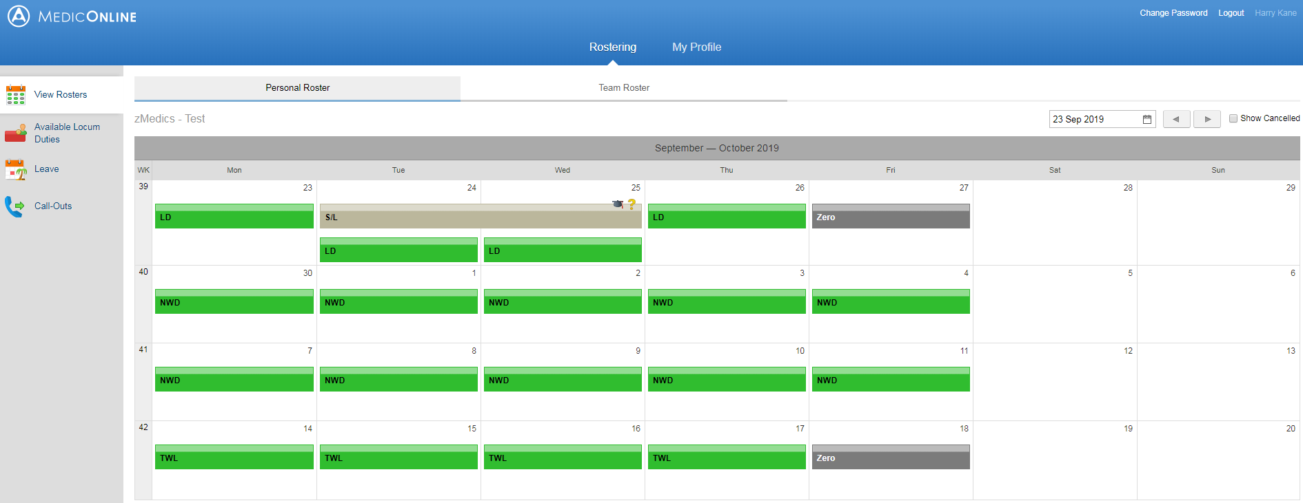

View Rosters – Team Roster
- My Team Roster – this tab will show your team and what shifts they are assigned to. This can useful for you to view if you are wanting to make a swap – you can provisionally see who you can swap with.
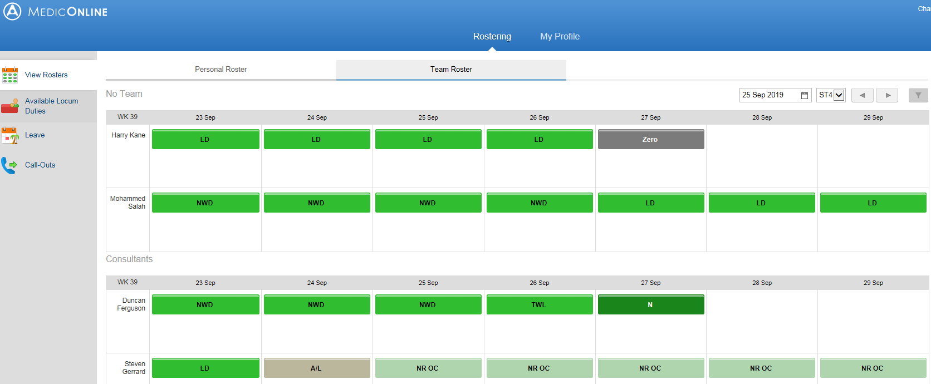

Available Locum Duties
- This tab will show all available locum duties. To book one of these shifts click here
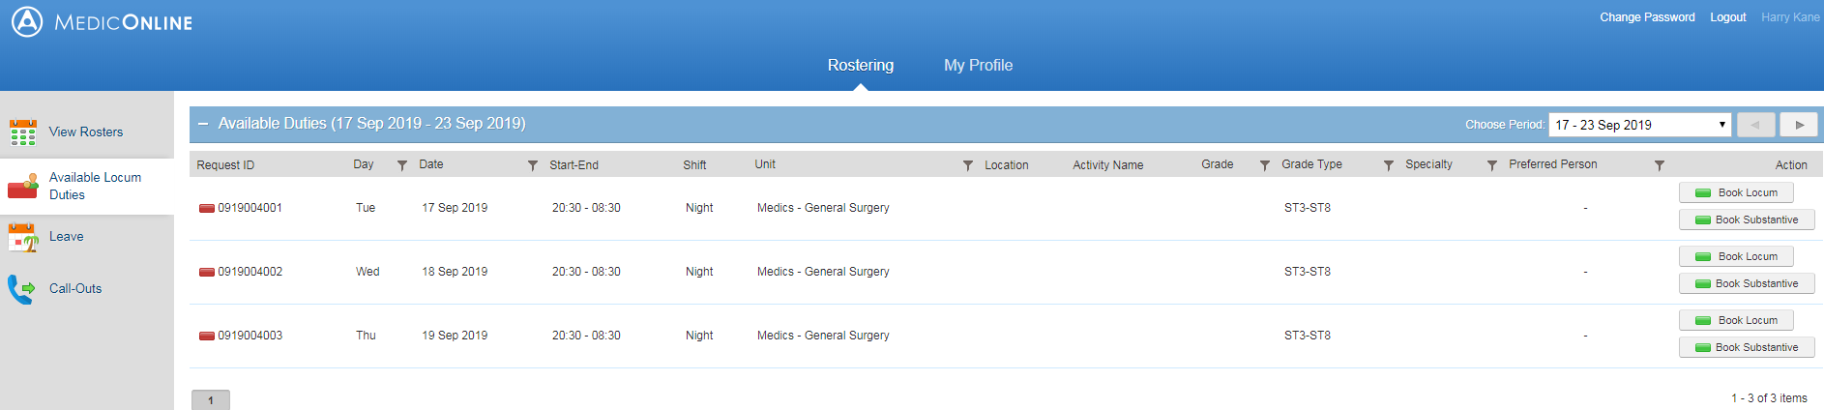

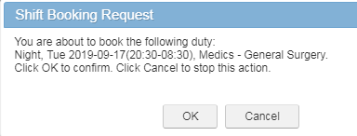
This box will appear, to book the shift, click ‘OK’.
Annual Leave Overview
- This tab will show you an overview of your annual leave; dates you have requested, dates that have been approved/declined, your entitlement and how many days remaining you have left.
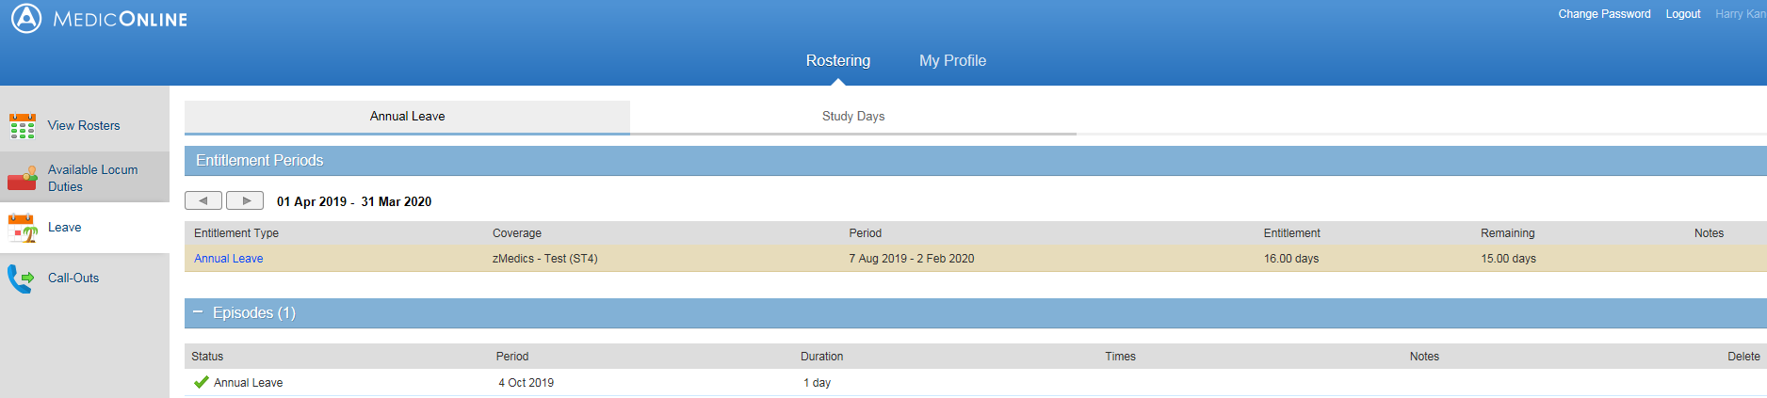

Requesting Annual Leave
- ‘Request Leave’ is still within the ‘Leave’ tab. This is where you can request your annual leave. To do this fill in the dates you would like to request off, then fill in how many days for example – 2 days and click ‘Set’. Below will show the shifts that will be affected if your annual leave gets approved on the system. You can see you will need to find cover for the 2 TWL shifts (in this case) – you can add notes so the speciality manager/leave approver can see you are trying to find a swap to accommodate your leave. Once happy – click ‘Submit Leave Request’.
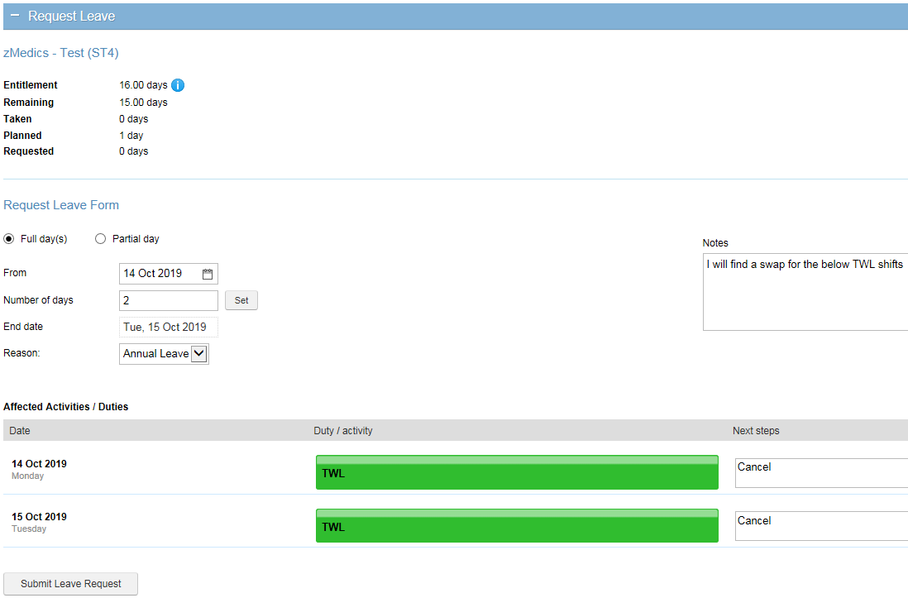
Once you have submitted your request, you will get the below message on your screen.
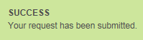

If you submitted leave below the 42 day notice period you will get this warning message.
Approved Annual Leave Confirmation
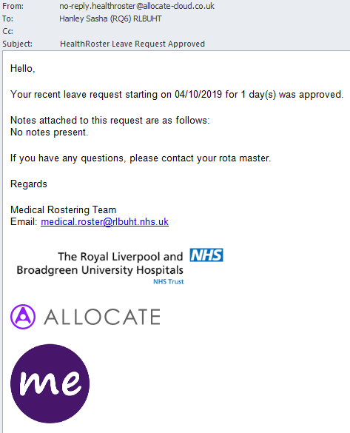
- Once your annual leave request has been approved you will receive an email and it will show on MedicOnLine your leave has been accepted.

Study Leave Overview
- This tab will show you an overview of your study leave; dates you have requested and dates that have been requested/approved/declined
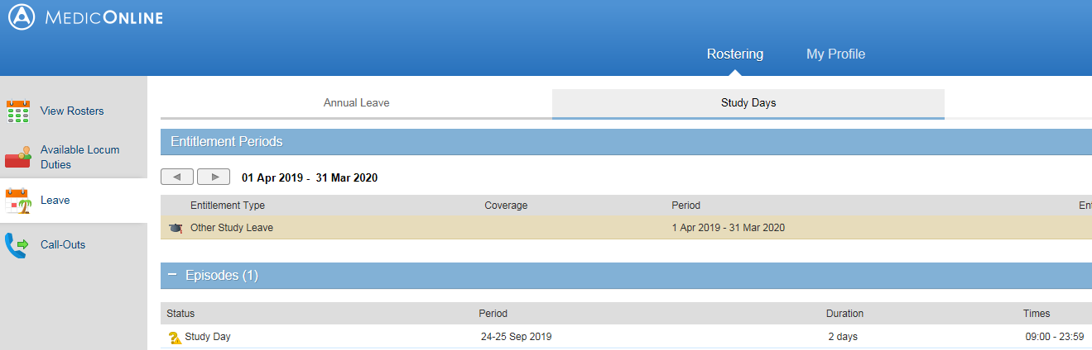

Requesting Study Leave
- To request study leave – Stay in the ‘Leave’ tab and click ‘Study Leave’. To do this fill in the dates you would like to request as study, then fill in how many days for example – 2 days and click ‘Set’. Below will show the shifts that will be affected if your study leave gets approved on the system. You can see below there are 2 NWD’s that will be affected. You can also add notes so your speciality manager can see this. Once happy – click ‘Submit Leave Request’. Your request will now be live on your screen showing as requested until it’s been approved.
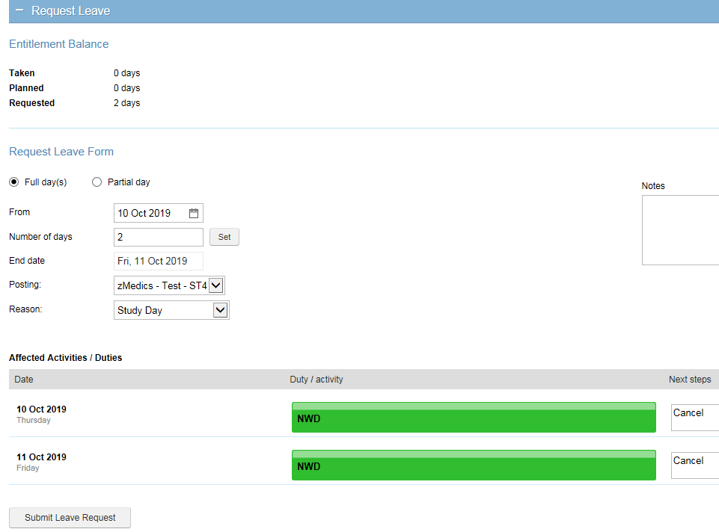
Approved Study Leave Confirmation
- Once your annual leave request has been approved you will receive an email and it will show on MedicOnLine your study leave has been accepted and your 2 NWD’s have been cancelled.
