HealthRoster (View Only)
- Log in with your details
- Once logged in, down the left hand side you will see 2 navigation tabs – ‘View Rosters’ and ‘Shift View’
- If you need to open new tabs so you can view 2 roster views at once you can click the ‘+’
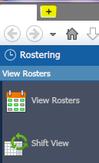

- To make sure you are looking at the correct ‘View date’ you can see this in the top ride hand corner. You can change this by clicking on the date and selecting another date from the calendar
Red circle = Today’s date
Monday 5th August 2019 is the date that is already selected, If you hover over any date (in this case 29th and click it) your view date will change to your selected date

- This is the view rosters tab, here you will find names of medical staff and what they are working.
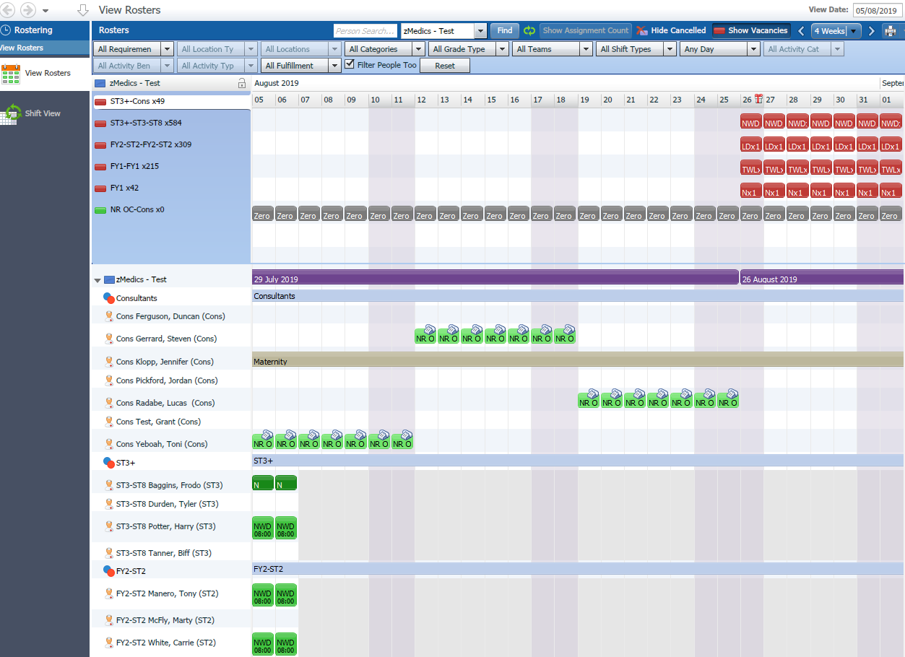
- You can filter at the top of the screen if you are looking for a specific requirement
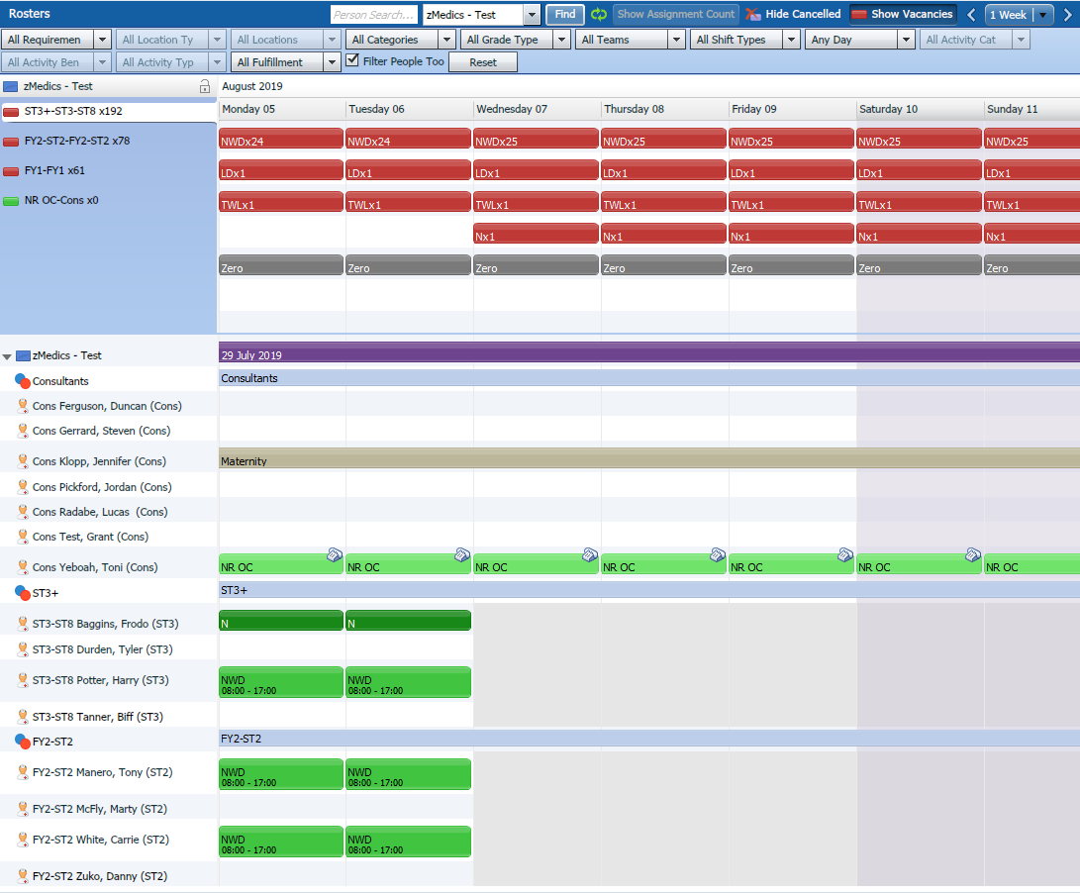
- To change your weekly view you have these options below. To change this you can click here ‘4 weeks’, Below is a 1 week view. This gives a more detailed view i.e. can see times of shifts.

This is a week view in Roster, as you can see there are times on the shifts
To move back and forth a week you can click the < and > arrows and this will move forward or back a week.
- Below are the vacant shifts in the ST3 rota. As you can see there is x24 NWD (Normal Working Days), x1 LD (Long Day), x1 TWL (Twilight), x1 N (Night), Zero (Rest Days)
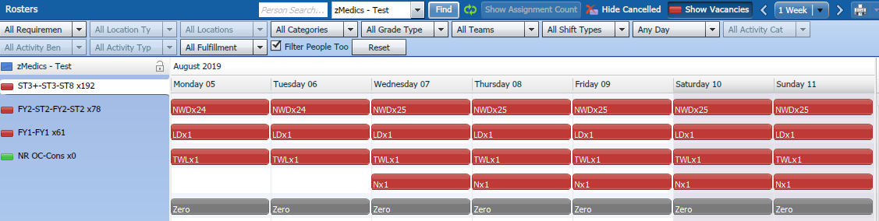
- The Roster is showing ‘All Teams’. Which consists of = Consultants, ST3+, FY2-ST2 and FY1. To view just a certain team for example: Consultants. Use the ‘All Teams’ drop down and select Consultants. This will reflect below.
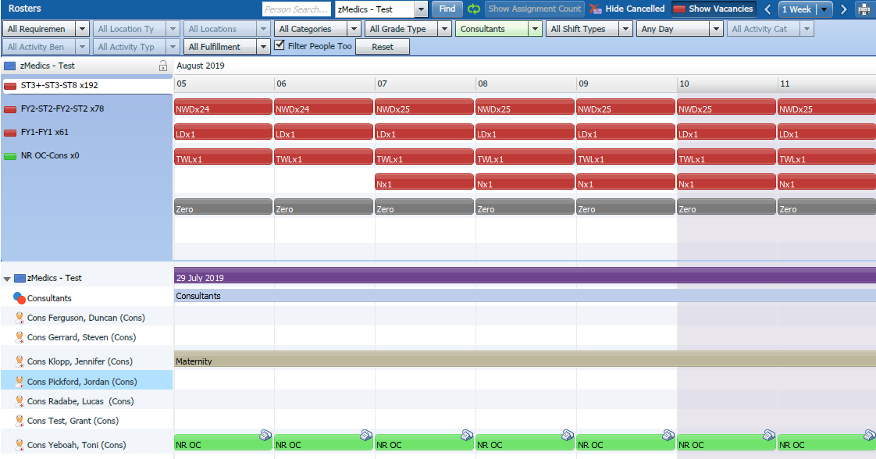
- Unavailability’s on the Roster
This list is all of the unavailability’s that can show on the live roster: Annual Leave, Sickness, Study Leave, Teaching, Induction, Bank Holidays, Maternity.
The staff members names are always down the left hand side with their allocated shifts on the row. The shifts are: On Call shifts and Normal Working Days.

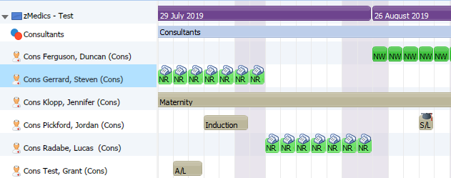
All available shifts will be in green (for example: the Normal Working Days and On Calls)
All Unavailabilities will be greyed out (for example: Maternity, Induction, Study Leave, Annual Leave)

Shift View tab
This tab will show you a different view of the Rosters. If you use the dropdown arrow this will show the red and green shifts/vacancies.
The green shifts are the shifts allocated to that staff member.
The red shifts are the vacant shifts.
