Approving Unavailability’s (Annual Leave/Study Leave):
- Once logged in, you will be able to see the Unit Summary. In this screen you will see ‘Awaiting Approval’ for Study and Annual leave and much more.
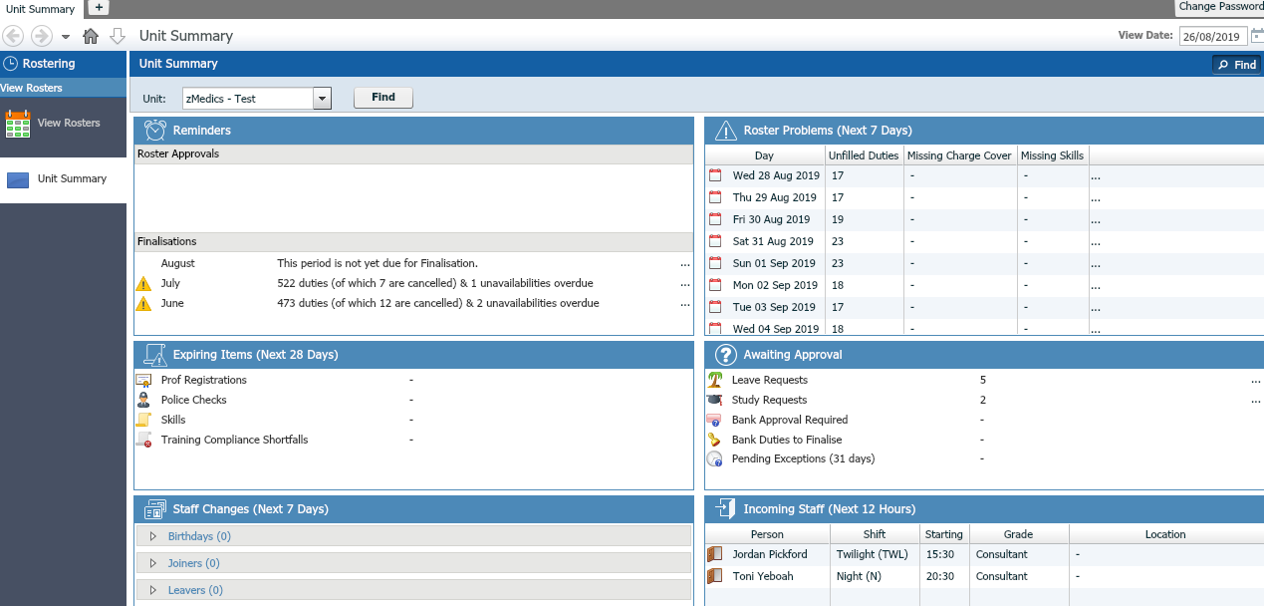
View Rosters Tab:
- Once logged in, you can go to ‘View Rosters’ tab. This will show you who has requested what day and if it conflicts with booked shifts.
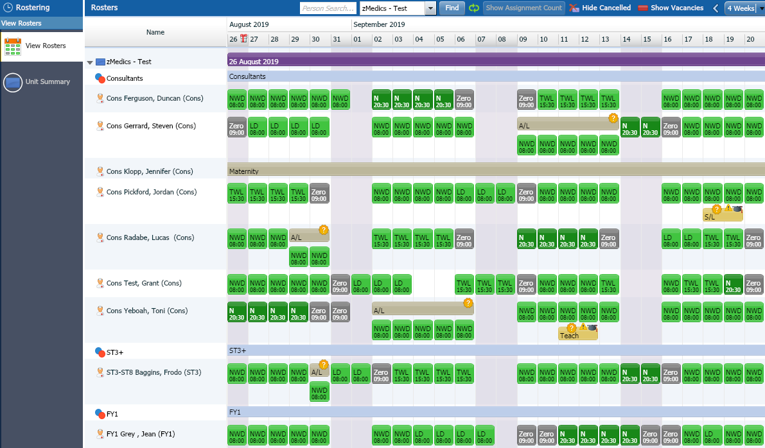
Viewing a List of Unavailability’s (Approving/Rejecting) 1st View
- You can view a list of requested Annual Leave & Study Leave, by clicking: ‘Unavailability’s’ & ‘Annual Leave & Study Requests’. Here you can see a list of the requested unavailability’s for the staff.
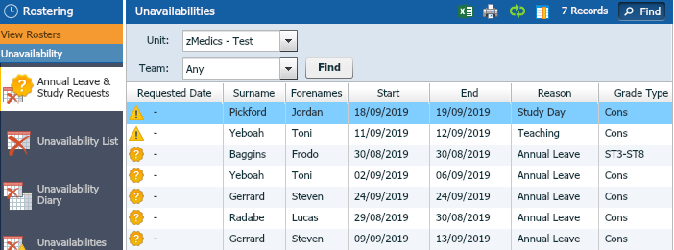

- There are 2 ways of accepting/rejecting requests. This is the first way to do this however if you wanted to view it differently (View to see who has requested, who is going to have to cancel/swap shifts, please look at page 6)
- You can either ‘Accept’ or ‘Reject’ the requests that have come through. To do this you can simply highlight the name, at the bottom of the screen are your options.
Viewing ‘Overlaps’:
- On the right hand side there is a tab ‘Overlaps’. This shows the overlaps of Drs who have requested the same day off/study leave. You can prioritise in order of requested date, if you are going to Approve or Reject.

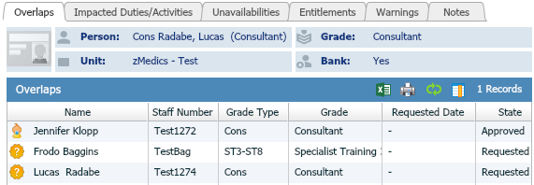

Viewing Impacted Duties/Activities:

- Before you accept the request. You can see if there are any impacted duties overlapping with the leave request. To view this, you can click on the tabs on the right hand side of the screen.
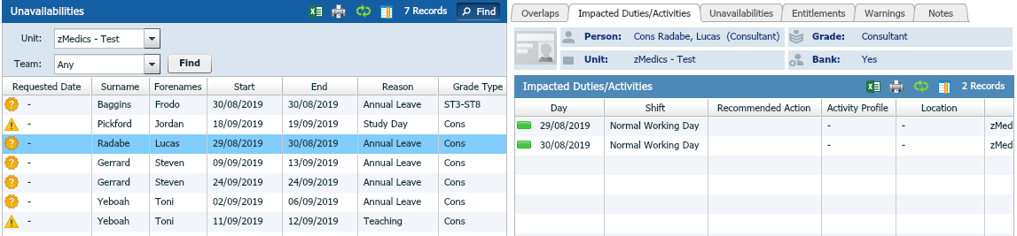
- As you can see there are 2 NWD’s that will be impacted if this leave gets accepted. These will need to be swapped with another Dr or rejected if you can’t get the impacted shifts sorted.

Viewing a Roster of Unavailability’s (Approving/Rejecting) 2nd View
- You can also approve Leave requests in the ‘View Rosters’ tab. This is the 2nd View. This may give a clearer viewing when seeing who else has requested a particular day off. For example:
As you can see on 30th August 2 members of staff have requested leave for that day.
If you wanted to approve or reject this leave on this screen you can. Right click on the ‘A/L ?’ and some options will appear (below) then simply accept or reject.

If approved, a purple icon will appear below the approved annual leave day. The purple NWD has been cancelled.
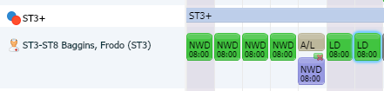
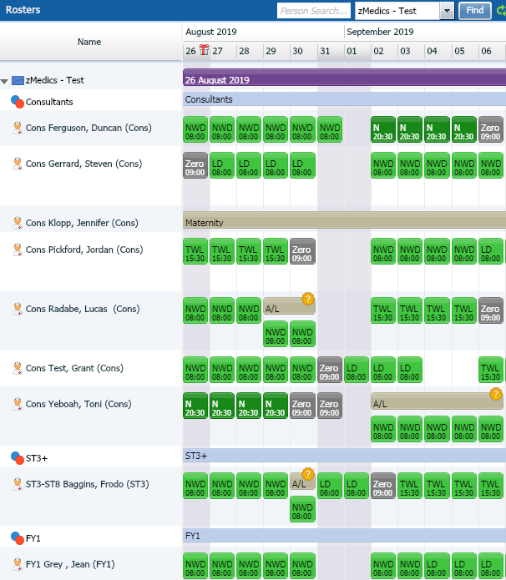
To View Entitlements, Remaining Leave & Adding Notes
- To view entitlements: you can click on the tab on the left hand side and see how many annual leave hours/days are remaining for ‘Lucas’ in this case.
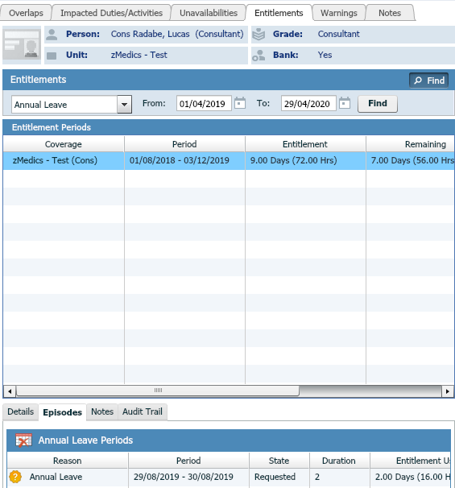
Notes tab:
- You can add notes here.

