Stress Risk Assessment
Please consult the stress at work Policy for full details. This is the short document with the stress risk assessment and Action Plan.
Purpose
Liverpool University Hospital Foundation Trust (LUHFT) recognises its legal responsibilities under with Health and Safety at Work Act 1974 and the Management of Health and Safety at Work Regulations and is committed in continuing to provide a safe and healthy working environment for our staff. The Trust also recognises that work-related stress is a major cause of occupational ill health and as such has a moral duty to ensure staffs mental wellbeing whilst at work.

The Trust will use the Health and Safety Executive’s Management Standards for Work Related Stress (MSWRS) to assist in the reduction of workplace stress. The HSE MSWRS identity six key potential stressors at work that, if properly managed proactively, can help to reduce work–related stress:

- Demands such as workload, work patterns and the work environment
- Control such as how much say the person has in the way they do their work
- Support such as the encouragement, sponsorship and resources provided by the organisation, line management and colleagues
- Relationships such as promoting positive working to avoid conflict and dealing with unacceptable behaviour
- Role such as whether people understand their role within the organisation and whether the organisation ensures that they do not have conflicting roles
- Change such as how organisational change (large or small) is managed and communicated in the organisation

Additionally, we will ensure that the staff member is supported with personal related stress, as we understand that will have an impact on their mental health at work.

Flow Chart
The trust employs two processes. The first is an annual stress risk assessment which will be completed by the team lead (this can also be used with departments undergoing change or have a high prevalence of stress). The second is an individual stress risk assessment which will be completed when an individual has identified that there are struggles as a result of stress. This may be identified by the staff member themselves, manager, occupational health, HR, management, health and safety or freedom to speak up.
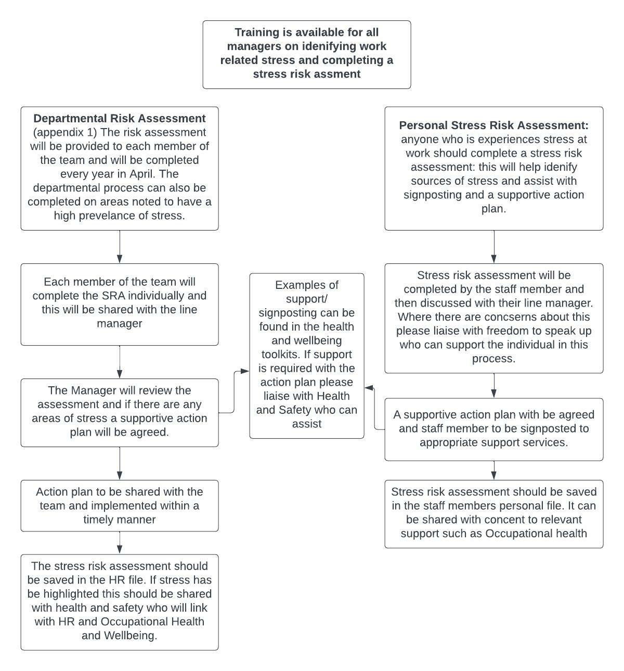

Procedure Guidance:
Managers who are responsible for an area/ward/department must undertake an annual departmental risk assessment using the Trust approved template which must include a documented and appropriate action plan.

Any actions identified on the action plans of either the personal or departmental risk assessment must be implemented within a reasonable timeframe, if not immediately. Managers also have a duty to refer any employee to Occupational Health Management Referrals (sitekit.net) or signpost directly to our staff psychology service. This can be completed using the following link Staff Psychology Service (sitekit.net)

Your department risk assessments should be stored locally in your Departmental drive. Where stress is identified please inform your health and safety and Health and Wellbeing Lead.

Each employee of LUHFT must complete an annual personal risk assessment which will be provided by their line manager. This assessment is mandatory and will help us to ensure that your health and wellbeing is being supported in work.

The Trust wants to give you all the support it can, and we have an in-house psychology and counselling service. This service is completely confidential as staff can self-refer using the following link: Staff Psychology Service (sitekit.net)

We also have a wealth of information available on the occupational health intranet pages Occupational Health & Wellbeing (sitekit.net)

The problems do not have to be related to work and the psychologists and counsellors will tailor the intervention to suit your needs. Sessions are available face to face, over teams or over the telephone.

Training

Current courses:

- Managing your own personal stress course
- Completing a stress risk assessment
- Sickness absence management course

Annual/ Departmental/ Individual Stress Risk Assessment

Name:
Job role/ title:
Have you had any sickness absence in the last 12 months:
If yes, please state how many occasions:

Section A: Your Health-Personal

Have you suffered from any of the following in the last 6 months?

 | Yes/ no | Is this normal for you? | Is work a contributing factor
Low mood
Feeling angry more than usual
Lack of care for yourself
Change in personality
Anxiety
Stomach upset
Fatigue
Frequent headaches
Apathy
Stress

Are there personal issues which affect your work on a regular basis? The following are examples Please tick/ circle if applicable.

- Financial worries
- Bereavement
- Relationship issues
- Family concerns
- Job insecurity you/ partner
- Carer responsibilities
- Illness of relative of friend
- Substance misuse
- Work/ life balance

Lifestyle:

 | Yes/ No: | Comments:
Are you sleeping well?
Are you eating well?

Are you drinking sensibly?

Engaging in hobbies/ interests?

Further Comments:

We have lots of supportive information and signposting on our staff hub intranet site about how to look after your health and wellbeing:

Please remember that that the Trust has a psychology and counselling service which can be accesses via the following link:

If you have concerns about your health, you should also talk to your GP and support is also available through occupational health and wellbeing.

Section B: What makes you stressed at work?

- Below are some known causes of work-related stress (the Health and Safety Executive calls them ‘stressors’).
- Please think about how much stress each one causes you.
- This survey only covers stressors at work. It’s not meant to include stress caused outside the workplace, although that can add to your work-related stress.

Instructions: for each of the following questions. Please mark which one applies to you.

1 = Strongly Disagree
2 = Disagree
3 = Neither Agree / Disagree
4 = Agree
5 = Strongly Agree

If you “agree or strongly agree” please provide further details in the box below.

The purpose of completing this assessment is to highlight where there are stressors in work and the develop an action plan with your line manager to support you.

Demands | Strongly Disagree | Disagree | Neither Agree  or Disagree | Agree | Strongly Agree
I do not have the time to complete my required work tasks
I struggle to take my agreed breaks
I have to work overtime to complete the tasks required
I often need to rush my work
I am often asked to do tasks at the last minute
I get bored in work as there isn’t enough to do
I have a health condition which affects my ability to perform the demands of the role

(If you answer agree/ strongly agree please complete the wellbeing at work action plan)

Further Comments

Role | Strongly Disagree | Disagree | Neither Agree or Disagree | Agree | Strongly Agree
I do not understand the requirements of my role and what is expected of me
My job description does not match my job requirements
I am often required to complete more than my role.
I am not able to fulfil my role requirements
There are adequate opportunities to raise concerns about my role and responsibilities
I do not feel that I have the correct training to assist me to do my role
I don’t enjoy my job role
I do not feel that there is any job progression
I do not have the correct equipment/ environment to do my job
Further Comments

Control | Strongly Disagree | Disagree | Neither Agree or Disagree | Agree | Strongly Agree
I am not able to choose when I do my work tasks
I am not encouraged to use my initiative
I do not get the opportunity to development my skills
I do not find my work challenges me
I cannot choose when to take my breaks
I am not given my shifts in sufficient time frame, and this affects my personal life.
I do not get asked about my working pattern
I have not been supported to manage work/ life with flexible working
I do not have opportunities to express my ideas and points of view
Further Comments

Support | Strongly Disagree | Disagree | Neither Agree  or Disagree | Agree | Strongly Agree
I do not get the opportunity to meet with my line manager and discuss work/ any concerns
I do not feel that support is provided with my work requirements, or any difficulties experienced.
I do not find that I can get support from my colleagues
I have no one to talk to at work.
I am not aware of the support that is available from the trust or how to access it.
I am not provided with feedback or support from my manager
We do not have regular meetings to discuss current trust information/ highlight positives and negatives and work together on a solution
Further Comments

Relationships | Strongly Disagree | Disagree | Neither Agree  or Disagree | Agree | Strongly Agree
I do not think that there is a positive culture in the workplace.
I do not have positive relationships with my manager
I do not have positive relationships with colleagues
I am not aware of any policies/procedures to prevent or resolve unacceptable behaviour
I do not feel that unacceptable behaviour is dealt with appropriately
I do not feel that I work in a supportive team atmosphere
If I had a problem, I don’t feel that I could approach my manager
I do not feel that there is equality within the team
Further Comments

Change | Strongly Disagree | Disagree | Neither Agree  or Disagree | Agree | Strongly Agree
I am not provided with information to understand the reasons for changes
I do not feel that my employer consults me regarding changes or provides opportunities for open discussion
I am not made aware of the probable impact of any changes to my job
I am not given training to enable me to facilitate changes within my job
I am not aware of any support that is available to assist with managing change
I do not feel equipped or resilient enough to manage change.
Further Comments

Appendix 5: Departmental Action Plan

Work Stressor: | Concern Raised: | Action Required: | Person Responsible for the Action: | Completion Date:
Work Demands
Work Role
Work Control
Support
Relationships
Change

Appendix 6: Suggested Actions

Work Stressor: | Concern Raised: | Action Required: | Person Responsible for the Action: | Completion Date:
Work Demands | Too Much Work:  Too Little work: | - Review work requirements: provide project work if too little work and a lack of engagement/ motivation was highlighted.  - Assist with prioritisation  - Review staffing: access bank or review recruitment if required  - Increase work with colleagues/ integrated working therefore reducing workload  - Instruct and train other staff in key areas so that common tasks can be shared  - Ensure regular 1:1 monthly basis and discuss workload. This will assist with difficulties becoming a crisis.  - Ensure goals and expectations are completed and understood  - Review rosters regularly: ensure staff are getting them in a timely manner  - Rolling programme of scheduled work: utilising diary and check ins  - Ensure regular breaks and lunchtimes are taken  - Attend training courses to assist with skill acquisition.  - Encourage and motivate staff through regular communication and engagement in team focus/ aims.  - Praise staff when work has been done well.  - Signposting to the staff hub: lots of information to assist staff to manage stress/improve their work life balance and signposting to staff support services: Psychology support/ Remploy
Work Role | Not understood. | - Review job description and discuss current work role and requirements to ascertain if they marry up  - Ensure understanding of job role: create a work plan and review requirements during 1:1  - Review conflicting role and agree where collaboration is required or whose responsibility the task is.  - Regular 1:1’s to discuss role, look at training needs and development opportunity.
Work Control | Low work control | - Increased control over work tasks. Set projects with increased ownership.  - Discussion of changes required in the work role and requirements. They understand how their job could be more efficient and productive with better outcomes.  - Increased support/ guidance required  - Review of training opportunities  - Review against work demand and work role as changes their will increase control.
Support | Lack of support | - Monthly 1:1’s: this may be agreed to be a weekly wellbeing conversation and a monthly review to include caseload/ discussion of current progress/ difficulties.  - Buddy support within the department  - Link support with someone with a similar role in another department  - Identify the wellbeing champion or mental health first aider in the department as a support network.  - Regular meetings with the team and ensure communication channels
Relationships |  | - Policies and procedures in place i.e. Bullying and Harassment Policy  - Signpost to staff hub. Resources available and referrals  - Access to mediation  - Access to training  - Ensure consistent communications with the team: regular meetings and 1:1’s in place.  - Other issues highlighted in this will inevitably affect the relationships within the department
Change |  | - Staff kept informed before and during change  - Redesign meetings to enable cross communication and allow to people to ask questions and have their say  - Distribute an agenda before meetings to allow people to prepare and distribute minutes of meetings  - Small group meetings or one to one meeting if the change is impacting people differently.  - Open culture during implementation of new systems etc.  - Ensure training is in place and consider individual difference in learning.  - Create a timeline of place of changes  - Encourage briefings and training sessions  - Software piloted and evaluated to iron out all issues before introduction.

