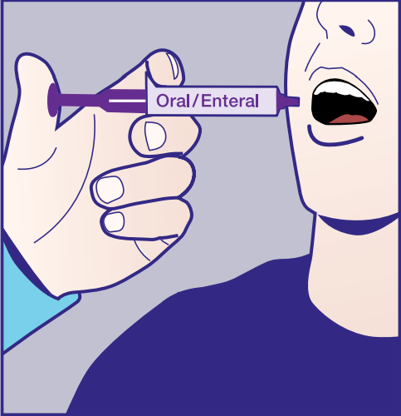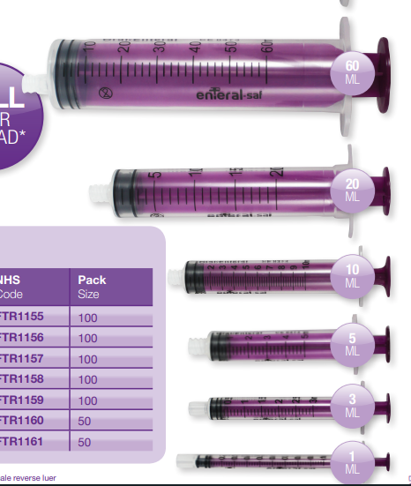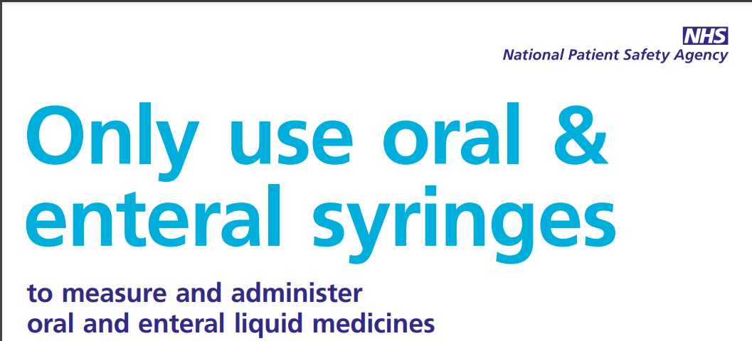

For oral / enteral administration syringes   
MUST be **PURPLE**

**STOP / CHALLENGE / REPORT**

No oral / enteral medicines should be administered in anything other than a **purple oral/enteral syringe**

*(unless the dose is in multiples of 2.5ml or 5ml orally where the appropriate end of a medicine spoon may be used)*

There have been 2 near-miss Never Events in the organisation whereby oral medications have been prepared and/or attempted to be administered via the intravenous route. Investigations remain underway.

This type of medicine error is defined by NHS England and Department of Health as a [Never Event](https://www.england.nhs.uk/wp-content/uploads/2020/11/2018-Never-Events-List-updated-February-2021.pdf). In 2007 the National Patient Safety Agency (NPSA) issued a patient safety alert which highlighted the potentially life-threatening risk of such wrong route errors.

**Purple** [oral/enteral syringes](https://gbukgroup.com/brands/gbuk-enteral/#:~:text=GBUK%20Enteral%20GBUK%20Enteral%20specialises%20in%20the%20supply,their%20own%20homes.%20Infant%20Feeding%20%26%20Breastfeeding%20Accessories) **MUST** be used for administration of **ALL liquid medicines given orally or via an enteral feeding tube.**

**Why** are **purple** oral enteral syringes used to administer oral liquid medicines?

* **Purple** oral/enteral syringes are reverse luer lock in design and cannot physically be connected to an intravenous (IV) catheters/cannula (the tip of the syringes are different) *(error PREVENT)*.
* **Purple** oral/enteral syringes are compatible with enteral feeding tubes.
* **Oral/enteral syringes have a purple plunger** to distinguish from an IV syringes and **provide a visual reminder** that the medication in the syringe must be administered via the oral/enteral route *(error ALERT).*

An IV (luer-tipped) syringe must **never**, under any circumstance, be used to administer oral/enteral medicines. This is to prevent the accidental connection of a syringe of an oral/enteral medicine to an IV cannula, resulting in IV administration and risk of patient harm.

**Action/mitigation:**

* Check the PRESCRIPTION – what is the intended route of administration?

If incomplete / unclear / unsure. **STOP** – seek advice, ensure prescription update, have a **Safety Conversation**.

* CHECK the drug, dose, formulation, route
* Oral / enteral: **THINK PURPLE!**
  + An appropriate size, **purple** oral/enteral syringe MUST be used to administer an oral liquid medicine if a medicine spoon or graduated measure cannot be used to measure and administer the prescribed dose.
  + A **purple** enteral syringe MUST be used for any enteral administration via an enteral feeding tube
* All clinical areas where oral/enteral medication may be administered must have an available stock of **purple** oral/enteral syringes
  + **Purple** oral/enteral syringes should be segregated from IV syringes
  + Consider having a supply of oral/enteral syringes available in the epma carts, in the CD cupboard and in close proximity to the liquid medicine storage area.
* **The following video is available on the HSIB website, which supports learning related to the risk of wrong route (IV administration of an oral medicine) error. The Medicines Safety Team would encourage all staff involved in any stage of the medicines process to watch the following video:**    
  [Training video: human factors in wrong route medication - YouTube](https://www.youtube.com/watch?v=jETyQ2q6AV0&feature=youtu.be) (link: <https://www.youtube.com/watch?v=jETyQ2q6AV0>)

For further support and advice please contact a member of the Medicines Safety Team ([medicinessafetyteam@liverpoolft.nhs.ukk](mailto:medicinessafetyteam@liverpoolft.nhs.ukk)).

If the issue relates to nutrition / enteral feeding tubes please seek support of the Dietician team.